­Response to referees’ comments for manuscript LT18371

Dear Editor,

Please find enclosed a revised version of our manuscript with revised title "Spontaneous Surface Charge Oscillations in Quasi-2D Systems via Dielectric Confinement ".

The authors would like to thank the comments and suggestions from the referees, which significantly helps improving the quality of this manuscript.

We have revised the manuscript carefully and thoroughly, the major changes in the manuscript are labeled in red.

In the following, we first summarize the main changes in the revised manuscript, and then present the itemized detailed responses/corrections to all the referees’ comments (our responses are in blue).

**Major Changes**

1. We revised the title and abstract to clarify the physical relevance of our model.
2. We revised the introduction for detailed description of the surface plasmonic waves.
3. We discussed the oscillatory effect observed in detail, and clarified a few technical details.
4. We re-runed the MD simulations according to the referee’s suggestions, and revised the related discussions about ionic structure.
5. We revised the conclusion, summarized the non-trivial behavior of electrostatic field found via our method.

**Response to the Referee A**

1. Negative permittivities are only relevant for non-zero frequencies, whereas the problems of interest and proposed approach are purely electrostatics. Although it is straightforward to plug in any value of \gamma and \epsilon's into the equations, how can the authors find justification of the results of clusters of like charged in Figure 4 in any physical systems, even for metamaterials?

Some recent works have shown that static permittivity of different kinds of material can be negative, and study about systems with similar confinements have also been reported in previous PRL article [10]. We consider such system can be achieved via proper choice of material.

Please see below for the detailed discussions we have added in the manuscript:

(page 1, paragraph 2) ‘Recent work has shown that negative static permittivity can be reached in a wide range of materials, such as metals [28], quasi-2D crystals [29], nano-particle [30, 31] and polymeric systems [32], making it possible for SPWs to be excited by a static field source.’

(page 2, paragraph 2) ‘Such systems can be achieved via tuning permittivity of the substrates material. For example, the permittivity of VO2 may change continuously from 0 to about -15 near 350K [28], and common solvents such as toluene, ethanoic acid, and pentanol also have permittivity in that region, so that in this case by tuning the temperature and changing the permittivity of VO2 we will get the proper gamma.’

1. Using periodic Green’s functions for polarizable surfaces has been proposed by other groups as well, e.g., Ref 21. The authors should discuss the similarities and differences between the proposed approach and previous efforts in more detail.

In our research, we used the idea of applying separation of variables to both side of Green's function (SI Eq. [1-3]) via plane wave expansion from previous research, and the rest are our original works.

* We develop the numerical method for not only discrete summations but also for integrals, so that we can handle interaction between charges in non-periodic systems.
* With proper renormalization, we extend the computable range of our method to $γ_{1}γ_{2}>1$ situations, so that it can be used to handle divergent problems which have never been solved.
* For MD simulation, we applied a new type 2D Ewald splitting, in which way the interaction can be divided into short-range and long-range parts, which converge rapidly in real and reciprocal space, respectively, so that our method can reach a complexity of $O\left(N^{1.5}\right),$ which is one of the highest among all method for dielectric confined quasi-2D charged systems.

1. The introduction of the cylindrically symmetric smearing Gaussian appears to give rise to a different kind of mathematical complexity than with the conventional spherical Gaussian, and the mathematical treatment is irrelevant to the underlying physics of the problem.

We agree with the Referee that the mathematical treatment is irrelevant to the underlying physics, using cylindrically or spherical symmetric smearing Gaussian will lead to the same result. However, using spherical Gaussian charges leads to a few difficulties: computing the dielectric effect of a spherical Gaussian charge is much harder than a cylindrically one, and the spherical Gaussian charge may overlap with the substrates, which is quite confusing, and solving these problems will induce even more complexity.

We also modified our method to reach the highest efficiency. We can show that mathematical complexity in that case is also given by $O\left(N^{1.5}\right).$

We added a new section in Supplementary Information for detail discussions.

(SI page 6) Section ‘Algorithm and Time Complexity’.

1. The authors stated that "Physically, Eq. (3) can be understood as screening the point charge only in the transverse directions, which is sufficient for quasi-2D geometry.". Subtracting and adding the Gaussian term is a mathematical tool to split the delta charge density into 2 terms which converge more rapidly in real and reciprocal spaces, respectively, and so saying screening the point charge only in the transverse directions is sufficient for quasi-2D geometry is not correct.

We are sorry for our inaccurate expression and thank the referee for the helpful suggestion.

A new description is given as

(SI page 1, paragraph 2) ‘Subtracting and adding the Gaussian term split the delta charge density into two terms, so that the calculation converges more rapidly in both real and reciprocal spaces.’

1. Although the short-range term G1 has an analytical form (Eq. 8) and the authors proposed to use Hankel transforms to cast it into exponentially decaying terms, the efficient numerical evaluation boils down to truncation in the lateral distances for a certain degree of (in)accuracy. The error analysis (SI, Fig 1) was done for \gamma close to 1, not for those substantially greater than 1.

In our new submission, we rewrite the expression using $γ$ but not $ϵ$, as given by SI Eq.(6). Based on this form, we show that for any given $γ$, the truncation errors are controlled by erfc($\sqrt{2k_{f}L_{z}}$) and erfc($k_{f}$/(2 $α$)) and are negligible.

The detail error analysis is given in:

(SI page 3) section ‘Optimal Quadrature Scheme and Truncation Error Analysis’.

1. Essentially it says to me that the short-range term is computed as a cutoff potential: the truncation error bound is dependent on the gap of slab geometry Lz (Eq. 24). Can the authors elaborate on the implication of this system-dependent error bound, compared to other methods, whose accuracy does not require system-dependent parameters?

It is correct that we treat the short-range term as a cutoff potential, and its truncation error bound is related to $L_{z}$, which we consider is natural because thickness of the system determines strength of the polarization and the calculation difficulty. Of course, we can tune the $k_{f}$ larger to keep the accuracy.

As far as we know, all method developed to compute effect of dielectric substrates do not accuracy that is system-independent, and solving system with thin gap has always been a challenging task. Using image charge method or solution of Green’s function are the major way. It is obvious that ICM is affected by the system parameters, more image charges are need for thicker gap and greater $γ$. For example, HSMA and ICMMM2D both have an accuracy depend on the parameters. Method directly using solution Green’s function are also affected, such as Levin’s method [21], its error bound also have a relation to $L_{z}$.

**Response to the Referee B**

1. The authors need to make explicit what permittivities are being considered in the medium (solvent) and in the substrates? Discussing the results only in terms of the gamma parameter that captures the dielectric contrast obscures the actual values of permittivities that are required to observe the claimed symmetry breaking in the ionic structure. The authors should make it clear that they only change the substrate permittivity when they tune gamma. I suspect this is the case, although I am not sure as the write up does not discuss this.

We thank the referee for pointing out the unclearness of our article. In our calculation, we used reduced unit in our calculation, and as shown in Eq. (5, 6, 9, 11), we directly used $γ_{1}$ and $γ_{2}$ to determine the dielectric boundary in our mathematical formula and simulations. We used the Bjerrum length $l_{B}$ to determine property of the solvent, and we took $l_{B}=3.5τ_{0}$ in our simulations, corresponding to water at room temperature, so that our method equivalents to tuning the permittivities of the substrates while fixing that of the solvent.

We added the following explanation:

(page 2, paragraph 3) ‘In our mathematical formula, we use $γ$ directly to represent the dielectric mismatch, and use $l_{B}$ to determine property of the solvent. During calculation, we tune $γ$ directly and that is equivalents to tuning the permittivities of the substrates while fixing that of the solvent.’

1. Are the substrate permittivity values explored in this work realizable in real materials? Authors should discuss at least some concrete connection with experiments in terms of the permittivities and stability of the metamaterials. Considering an example of the solvent being a liquid such as water with a permittivity of epsilon=80, when they show results for gamma = 10 and -10, they seem to be considering substrate permittivity of epsilon’~-65 and -97 respectively. Are these permittivities realizable in real materials such as the metamaterials noted by the authors?

The other Referee also expressed similar concerns about unrealizable negative permittivities in real materials. Although we still did not find materials with permittivity of exactly -65 or -97, recent works reported that static negative permittivities can be realized in a wide range of materials, and study of system with similar confinement has also been reported in previous PRL article [10]. We have made the following changes to the manuscript, which hopefully clarify our procedure:

(page 1, paragraph 2) ‘Recent work has shown that negative static permittivity can be reached in a wide range of materials, such as metals [28], quasi-2D crystals [29], nano-particle [30, 31] and polymeric systems [32], making it possible for SPWs to be excited by a static field source.’

(page 2, paragraph 2) ‘Such systems can be achieved via tuning permittivity of the substrates material. For example, the permittivity of VO2 may change continuously from 0 to about -15 near 350K [28], and common solvents such as toluene, ethanoic acid, and pentanol also have permittivity in that region, so that in this case by tuning the temperature and changing the permittivity of VO2 we will get the proper gamma.’

1. However, I am not convinced by the explanation given to explain the oscillatory force profile for the gamma =+10 case. Here, I would have expected that the image charge and the induced charge density is highly positive, and therefore the repulsion should be enhanced. Authors should expand on their explanation: “we attribute this to the complicated multiple scattering of the polarization field between the confinement substrates.” Do the induced charges on one of the substrates, which I would expect to be positive nearest to the real positive charge (as shown in the inset), produce a negative induced charge on the other substrate? What is the induced charge density generated on the substrates when one considers only 1 real charge in the center of the confinement; does this also have an oscillatory pattern? If yes, why?

In our new submission, we further explored the electrostatic field by ions confined by dielectric substrates with the negative permittivity, and the results are shown in new Fig. 2(a).

The induced charge on the surface also interacts with the opposite substrate, the process is similar to reflection of the image charges, and the sign of the second order charge depends on the sign of $γ$, positive for positive and *vice versa*. We found that for both cases, the short-range repulsion or attraction are enhanced as expected, because of the strong surface charge at the center of both substrates.

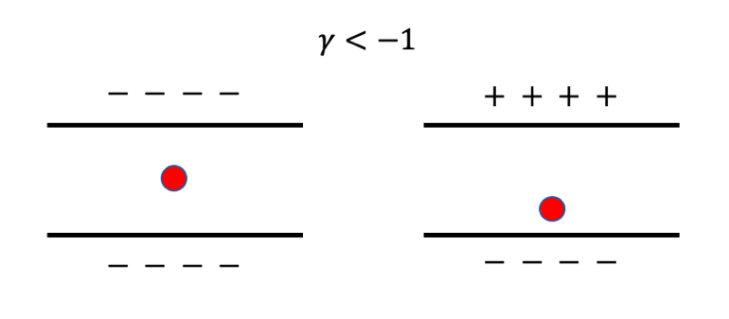For $γ< -1$ cases, a cation will induce negative surface charges on the substrates, and they will produce positive induced charges on the opposite sites. Result of such process depends on the position of the source charge, when the ion is near the center, surface charge on center of both sides will be negative, and when it is nearby one substrate, charge on center of opposite substrates will be some kind of anti-symmetric, on the nearby side it will be negative and on the faraway side it will be positive, as shown in the figure below.

For $γ> 1$ cases, a positive surface charge will also induce positive charge on the other side, so that at the center charge on both sides will be positive, as shown by the figure below.

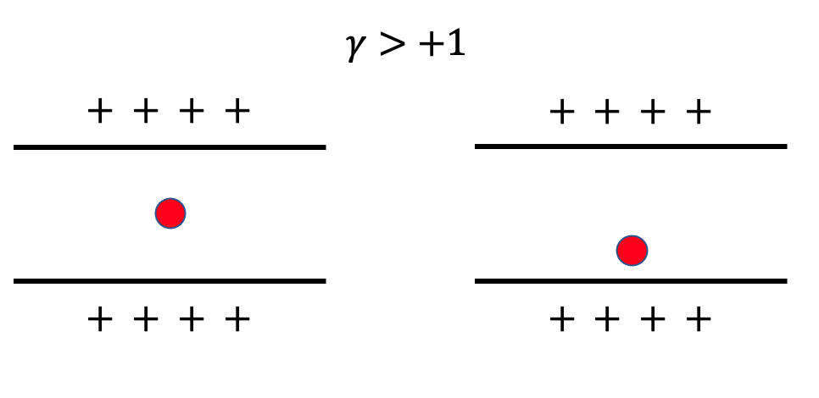

In both cases, due to the reflection process, the surface charge is much stronger than normal cases.

We also found that for both cases, the long-range behaviors of the fields are both oscillatory, and the period of oscillation are inverse proportion to the resonance frequency of the quasi-2D systems defined in main text as $k_{0}=\ln{γ_{1}γ_{2}}/\left(2L_{z}\right)$, which shows that $γ_{1}γ_{2}=1$ is a continuum phase transition point of such effect, when $γ_{1}γ_{2}→1^{+}$, $k_{0}→0^{+}$ and $λ→∞$, so that if $γ_{1}γ_{2}<1,$ there is no oscillatory effect found.

We made the following changes in main text:

(page 3, paragraph 1) ‘However, when |γ| > 1, the result is highly non-trivial, as shown by purple and red lines. The short-range interaction behaves as strongly repulsive or attractive when γ = 10 or −10, respectively, which can be regarded as an extension of that in γ < 1 cases. Interestingly, the field did not decay to 0 but shows to be oscillatory in the transverse direction, which is different from previous observations.’

(page 3, paragraph 2) ‘At the center, the strong surface charge dominate in both cases as expected, so that even reverse the field. For the long-range field, the surface charge also oscillates along the transverse direction, caused by the intense polarization at the center and enhanced by the bi-surface reflection, generating corresponding fields The oscillatory field here is different from other electrostatic fields but similar to that of SPWs, and here reflection between the substrates is the reason. It is also shown that for γ > 0 and γ < 0 cases, polarize charge and field in z on the opposite substrates are anti-symmetric and symmetric, respectively, which is self-consistent with the definition of γ .’

1. Is gamma = -1 result exactly at -1 or at a value near -1? gamma = -1 corresponds to a substrate permittivity of 0 (which authors should explicitly note). Following equation 2, what is the induced charge density on either substrate for this case? Does this not diverge?

As mentioned above, in our calculation we use $γ$ directly and do not need to convert them into $ϵ$, so that $γ=-1$ is an exact value and can be directly reached.

When $γ=- 1$, if we take $ϵ=1$ and $ϵ^{'}→∞$, the surface charge density is then given by $σ=ϵ_{0}\left(1-ϵ/ϵ^{'}\right)E_{z}→ϵ_{0}E_{z}$, so that is not divergent, and our numerical results shows that there is no much difference between $γ=-1$ and $γ=-0.95$ cases.

­­

We removed $γ=±1$ cases from Fig. 2(a), and added $γ=±0.95$ and 0 cases instead, which can be used to compare with results of ICM.

1. Both T_r and gamma depend on the solvent permittivity epsilon. It seems that T_r is changed by tuning the temperature and not epsilon; otherwise the two control knobs are not independent. If this is indeed the case, the authors should note explicitly. It should also be noted that changing T_r changes epsilon_LJ, i.e., the characteristic steric interaction between ions.

Sorry for the mistake we made here, in these simulations, we made $ϵ_{LJ}$ unchanged while tuning $T_{r}$. In calculation, we use $T_{r}$ to determine the average speed of the particles.

1. However, I suspect the opposite configuration of cations accumulating near the top substrate and anions accumulating near the bottom one has the same energy. The authors should provide a discussion of this degeneracy; it’s not clear if density profiles shown are true equilibrium results or correspond to an ionic system that is trapped in a metastable free-energy state?

It is correct that our system is symmetric in z direction and these two cases are degenerate. The property is shown better in our new MD results by Fig. 3(a) and SI Fig. 4(a, b), we found that the ions form two types of clusters and occupy two sites of the 2D square lattice. When $γ> 1$, the clusters are $\left(++\right)$ and $\left(--\right)$; and when $γ<-1$, they are ( $+-)$ and $\left(-+\right)$, which are degenerate as two types of elements in the lattice.

We agree with the referee that it is possible that the system is trapped in meta-stable state, but we consider the lattice liked structure shows the ideal state of the system due to following reasons.

Firstly, we found that our system has a great tolerance of defects, among a few sites may not be occupied by ions, which means that the lattice liked structure is highly stable.

Secondly, we tried annealing process for our system. we first set $T_{r}=10$ and run for $5×{10}^{5}$ step so that the system reaches equilibrium in a high $T_{r}$, and then use ${10}^{6}$ steps to cool the system into $T_{r}=1$, and then run for another $5×{10}^{5}$ steps. The final states have the same structures as the previous ones, so that we regard it as an equilibrium result but not a metastable one.

Thirdly, we run the simulation with different setups but random initial particles’ positions and velocities for multiple times, and these simulations all gives the same results, as shown by the figure below, which also prove that our results are not meta-stable ones.

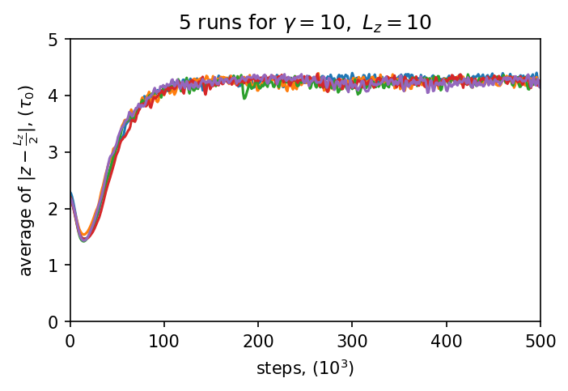

1. The electrostatic energy of the system is bounded from below for materials with positive permittivities. It is not clear to me if this energy has a lower bound minimum (minima) for the materials with negative permittivities considered here? What are the steady-state average electrostatic energies associated with the systems explored in Fig. 3?

We consider that the electrostatic energies of an ion confined by dielectric substrates with positive or negative permittivities are bounded by induction of the repulsive shift-truncated Lennard-Jones (LJ) potential energy, which models the radius of the ions and prevent them from getting infinite close to other ions and the substrates, so that leads to a lower bound of the system energy.

The average electrostatic energy of the system is about $-20±2k_{B}T$ or $-34±2k_{B}T$ when $γ=10$ or $-10$, respectively, which are much smaller than the initial state (about $-2.5k_{B}T for both cases$).

1. The authors should explore the effects of finite system sizes on the observed profiles. For example, if the total number of ions is increased from N=100 to N=500 or 1000 (keeping the volume packing fraction and confinement length the same), do they see any differences in the average ionic density profiles?

We really thank the referee for this suggestion. We find that the boundary effect can greatly influence the field if we take $L_{x}=L_{y}=30τ_{0}$, so we enlarge the system to $L_{x}=L_{y}=180τ_{0}$ so that in the center region ($r<30τ_{0}$, where $r$ is the distance from the center) the field is almost the same to that of a non-periodic system, as shown by the figure below, which shows the interaction between two charges near the substrate with or without the periodic boundary condition. So that we consider the boundary effect is weak enough. We also increased the number of the particles to $N=40$ 0 and 600.

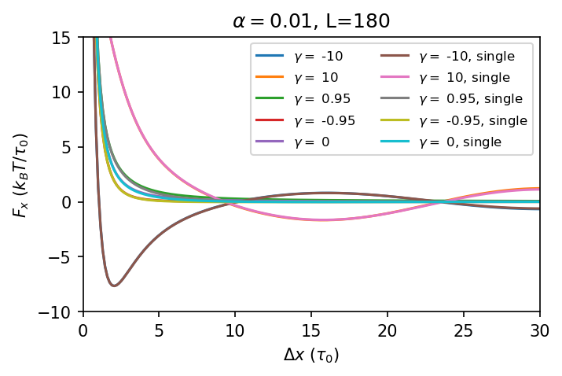

As shown above, we find that in this case the systems behave differently, which is more likely to be the equilibrium state of a real infinite system. Our new results show that $L_{z}$ and $γ$ determine the distance of the clusters, and $N$ only influences average number of particles in a single cluster. We also tested system with the same volume packing fraction but different size ($L_{x}=L_{y}=90$), and found that the distributions are exactly the same.

The following change has been made:

(page 4, paragraph 2) ‘In all the Molecular Dynamics (MD) simulations performed, we fix box size in $xy$ as $180τ_{0}×180τ_{0}$ so that the boundary effect can be ignored at the central area, then we tune $L_{z}$ and γ to change $k_{0}.$’

(page 4, paragraph 3) ‘Interestingly, we found the ions are induced to form clusters, and the clusters order periodically in both γ > 1 and γ < −1 cases near the substrates in the transverse direction, as shown in Fig. 3 (a); in the vertical direction, the ions are distributed near the substrates, and are paired with another cluster on the opposite side anti-symmetrically and symmetrically, respectively. The structures of the clusters are also different, when γ < −1, the ions are closely packed, and when γ > 1, they form ion liquid, because the interactions between charges are attractive and repulsive, respectively, as shown in Fig. 2 (a).’

1. I suspect that the low-energy ground state for this case is also degenerate and the authors should provide a discussion of this degeneracy and if the shown results are true equilibrium results or correspond to an ionic system that is trapped in a metastable free-energy state?

Our response to question 6 may also be used to answer this question. In our new simulation results, we found that the behaviors are similar no matter $γ$ is greater or less than $1$. With the same reasons, we consider that our results present the true equilibrium state.

The average distance for ions to $z=L_{z}/2$ plane by five different runs are given below.

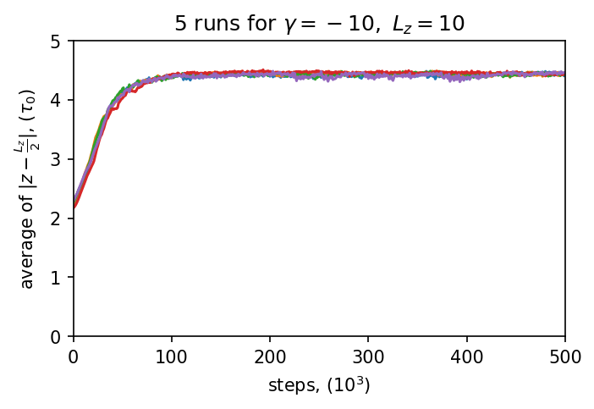

1. How different are the representative induced charge densities (associated with a typical ionic configuration, e.g., the one shown in Fig 4a) compared to the gamma = +10 case?

We plot the surface charge density of both case in the new Fig. 3(a), which show that the chess board-like charge density, surface charge below the ions has the opposite sign to the ions so that trapped them as clusters. The main difference between them is that for $γ>1$ cases, the surface charges on opposite substrates are symmetric and when $γ<-1$ they are anti-symmetric. Another difference is that, when $γ>1$, for example the surface charge exactly below a cation is still highly positive while the surrounding ones are negative.

1. Taking the example of epsilon=+80 (water), in going from gamma=10 to gamma=-10, the substrate permittivity is tuned from epsilon’=-65 to epsilon’=-95. What is expected at epsilon’=-80 (a value in between the two studied permittivities)? For epsilon’=-80, gamma tends to infinity. Can the method handle this case? In general, given the focus on materials with negative permittivities, what happens to the ionic structure when epsilon’=-epsilon?

In this case the reflection rate is divergent and the system is mathematically ill defined, and there will be no solution for Poisson's equation for even a single slab, so that our method cannot be used to solve such problem.

We may have a check of the limit at $γ→∞.$ According to our new result, $λ×k_{0}∼2$, and $k_{0}=\ln\left(γ_{1}γ_{2}\right)/\left(2L_{z}\right)$, we suppose when $γ→∞, λ→0$, so in the field will oscillate with an infinite frequency and may need further treatment to be understood.